Meet the founder
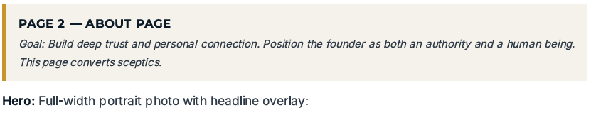
HEADLINE: Your greatest strength can become your greatest liability under pressure.
Subheadline: Drive becomes intensity. High standards become control. Responsibility becomes over-responsibility. Great leadership requires range.
PHOTO:
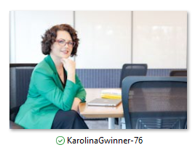
Or
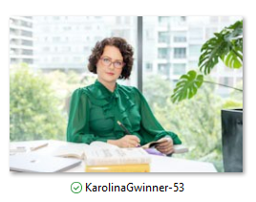

The moment I understood what peak leadership really meant
Leadership is revealed under pressure
Over the years, working with leaders across industries and cultures, I began to notice something. The leaders who made the greatest impact weren’t necessarily the ones who knew the most, worked the hardest or had the most impressive titles. They were the ones who could stay clear, grounded and influential when the pressure was on.
That was when I began to see peak leadership differently: not as performing at maximum pace or intensity, but as being able to access your best when it matters most.

My QUOTE:
Pressure doesn’t create your leadership. It reveals it.
When the stakes rise, your habits, patterns and ability to regulate yourself become impossible to hide.

What I saw missing in traditional leadership development
- Knowing versus being able to do it when it matters
Leadership development offers us an abundance of models, frameworks and strategies. But knowing what good leadership looks like and being able to embody it in a difficult conversation, a boardroom, a crisis or an exhausting week are two very different things. I became obsessed with closing that gap: the space between knowing and consistently being able to perform under pressure.
- Developing leadership skills but overlooking the habits that drive human behaviours
A lot of programmes and investment goes into teaching leaders how to communicate, influence, delegate or coach, yet often pay far less attention to the human habits that drive adoption of new skills such as: how they manage their attention and energy, emotional regulation, the ability to think clearly under pressure. But when those foundations are compromised, even the best leadership tools become much harder to access.”
- Leadership development often ends when the workshop ends
I also saw how easily powerful insights disappeared once leaders returned to full calendars, competing priorities and everyday pressure. Enthusiasm evaporated quickly and got replaced by a daily grind. The issue wasn’t a lack of intelligence or motivation. The challenge was turning insight into behaviour, and behaviour into a habit that is sustainable. My work aims at bridging that gap between learning about leadership and actually living it long after the programme is over.

Why I built Lead At Your Peak
Building a proven and integrated development system, not another collection of best tips
After years of working with driven and ambitious leaders and chasing any research study that could help them optimise how they lead and perform, I realised that the most powerful tips tend to be ineffective or short-lived if they come without a well-structured foundation. So, based on everything that I knew, observed and taught, I decided to build frameworks that provided such a solid structure and foundation. They help leaders understand the patterns shaping how they think, respond, communicate and influence under pressure.
Lead At Your Peak was born from that ambition: to help leaders strengthen the inner foundations and align it with a way they want to lead. This allows them to show up and lead at their best even when the stakes and pressure increase.
Photo: future proofing leaders
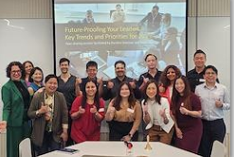

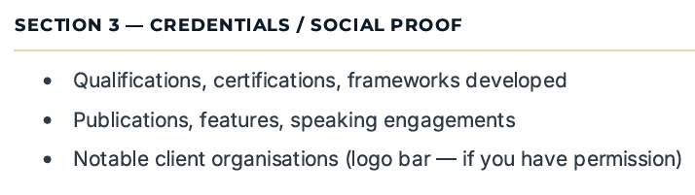
Karolina Gwinner is a leadership speaker, facilitator and executive coach who helps leaders and teams elevate presence, strengthen influence, and perform at their peak in fast-paced, high-pressure environments.
With a proven track record across APAC, she has partnered with Fortune 500 companies to drive meaningful behaviour change, enhance leadership effectiveness, and create tangible business outcomes.
Certified in Brain-Based Coaching by the NeuroLeadership Institute, Karolina brings practical, neuroscience-backed strategies to her work with leaders and teams, enabling them to build trust, clarity, and credibility so that they can lead with greater impact.
In 2024, she was recognised as a LinkedIn Top Voice for her insights on leadership and peak performance. Her contribution to advancing women in leadership also earned her recognition as a Knowledge Partner of the Women Leaders Institute from 2019 to 2023.
Karolina is a professional member of Keynote Women Speakers, Asia Professional Speakers Association, and the Global Speakers Federation.
Connect with Karolina on LinkedIn: https://www.linkedin.com/in/karolinagwinner/
Karolina is a speaker, facilitator and executive coach who equips leaders, senior executives, and teams across APAC to elevate presence, influence, and performance. With over a decade of experience partnering with Fortune 500 companies, she designs and delivers neuroscience-backed, results-oriented learning solutions that drive measurable business outcomes.
Certifications
Certified as a Brain-Based Executive Coach by the NeuroLeadership Institute and trained by the Human Performance Institute, Karolina brings evidence-based rigor to behavioral and organizational change. She facilitates the Miki Island high-performance simulation and conducts insight-driven leadership and team assessments to enable data-informed, targeted learning interventions. Karolina holds certificates in Creating Leadership Development Programs and Virtual Instructional Design from the Association for Talent Development.
Accomplishments
- Recognized thought leader - named a LinkedIn Top Voice (August 2024)
- Co-author of “Breakthrough: Secrets of Growth, Happiness, and Bouncebacks from Women Around the World”
- Host of the Leaders' Watercooler newsletter with over 1,000 subscribers
- Former Knowledge Partner of the Women Leaders Institute
Background
- Corporate background in financial services, technology and recruitment (Merrill Lynch, BNY Mellon, Hewlett-Packard).
- Polish-born, based in Singapore for 13+ years.

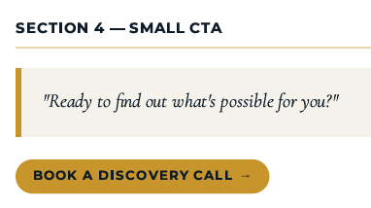

SKIPPING FOR NOW, MAYBE WILL USE LATER:
What drives me every day
The moment a leader stops proving and starts leading
The moments I value most are often subtle. A leader stops over-explaining and speaks with conviction. Someone who has been carrying everything learns to create ownership in others. A senior executive walks into an important conversation grounded rather than consumed by the need to prove themselves.
Those shifts can look small from the outside, but they can completely change the way someone experiences leadership. When a leader becomes more grounded, intentional and effective, the impact spreads: conversations change, teams become stronger, people take greater ownership and the environment around that leader changes.
That ripple effect is ultimately why I find this work so important and meaningful.
Photo: KarolinaGwinner-79
